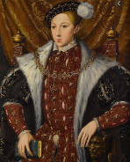
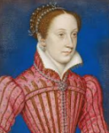
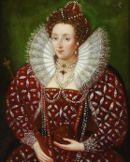
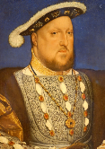
Year 5 Tudor Knowledge Organiser
Key people

Henry VIII Elizabeth I Queen Mary of Scots King Edward
Henry’s daughter Henry’s Daughter Henry’s Son

- The Tudor period is the period between 1485 and 1603. This was when the Tudors were the ruling family in England.
- The first Tudor monarch was King Henry VIII.
- Henry VIII defeated Richard III in the Battle of Bosworth in 1485.
- Henry VIII ruled, as King, until he died in 1509.
- House of Lancaster and House of York were rivals.
- Henry VIII joined the two houses together and created the Tudor Rose also known as the Union Rose.
- Henry VIII is famous for having 6 wives and he beheaded two of them.
- The exploration of America was during the Tudor period.
- Sir Walter Raleigh found America and introduced the potato and tobacco in England.
- Sir Francis Drake was the first Englishman to sail around the world.
- Over 70,000 people suffered death during Henry VIII’s reign.
- Hampton Court was Henry VIII’s pleasure palace, where he spent most of his time entertaining people.

DID YOU KNOW?
- Tudors loved meat, but they didn’t have fridges so they preserved their meat by rubbing salt on it.

An example of Tudor Roses

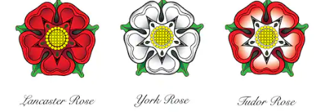

Key vocabulary:
Reign Exploration Monarch Defeated Gown Ruff Kirtle Gallows
Hampton Court Jousting Battle of Bosworth
Maths | English | History/Geography/Science | Art and DT
Know all your times tables to 12 x 12. | Read a book related to the Tudor times and write a book review for the class. | Find out the importance and link between the Spanish Armada and the Tudors. | Create a magazine cover for a Tudor magazine. What were the women/children wearing? What colours or fabrics were fashionable?
Divide a page into 4 – in each section show how you add, subtract, multiply and divide fractions. | Write a letter from a member of Hampton Court showing how people were treated during the Tudor time period. | Record 5 interesting facts about the Tudors – write them as a list or a short paragraph. | What did the Tudors eat? Design a Tudor menu for either a feast at the Royal Palace or a day in a normal Tudor home.
Create different 4 or 5 digit numbers. Add and subtract them. Use the inverse to check your answers are correct. | Research William Shakespeare and write your own play script. | Compile different fact files about key people in the Tudor times. | Design a Tudor home, explaining which materials you would use to create it.
Draw in your book how to multiply and divide whole numbers by 10, 100 and 1000. | Write a diary entry about the life of a Tudor child. | Research a key explorer in the Tudor time and create a poster to present your learning. | Design a Tudor board game and write instructions to go with it.

Here’s some space for you to design your own homework tasks!
Have fun!
Task 1:
Task 2:
Task 3:

