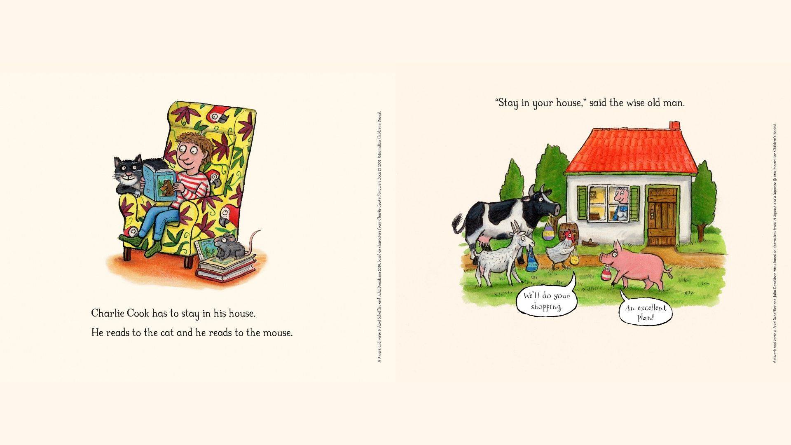

The Gruffalo, Stick Man and the Smartest Giant in Town lend a paw, a stick and a hand to help with the coronavirus effort

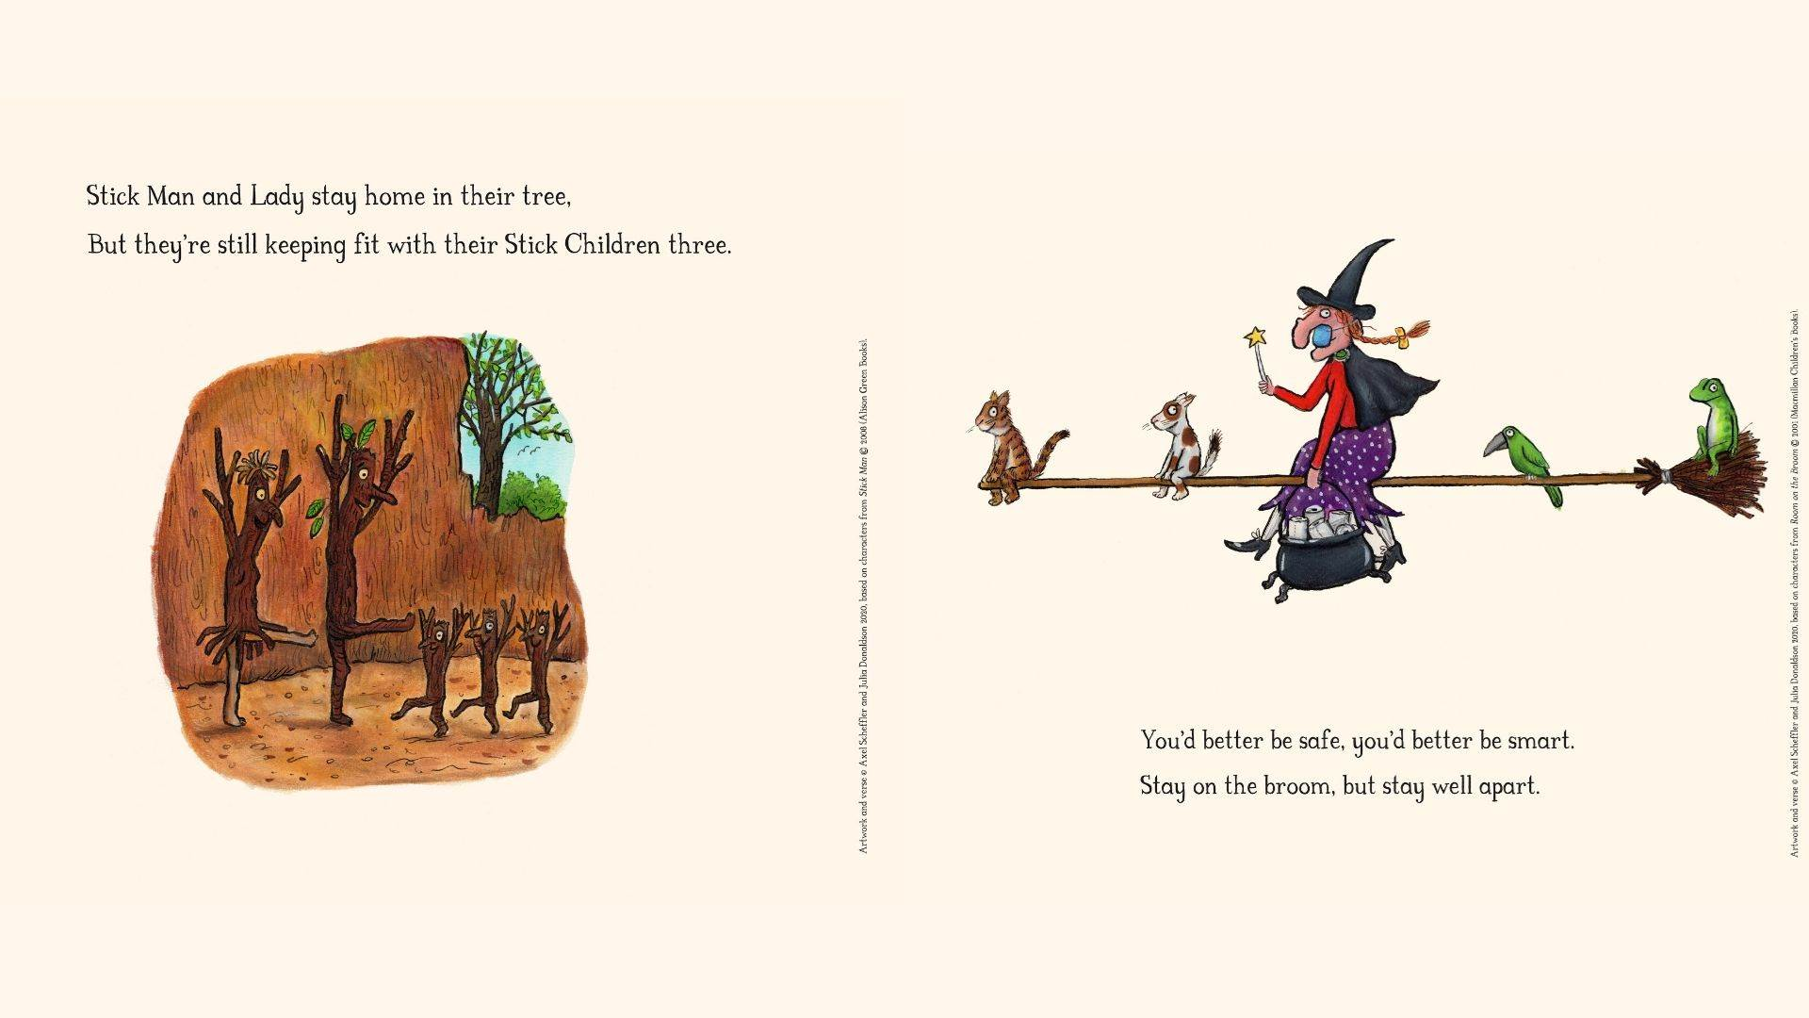

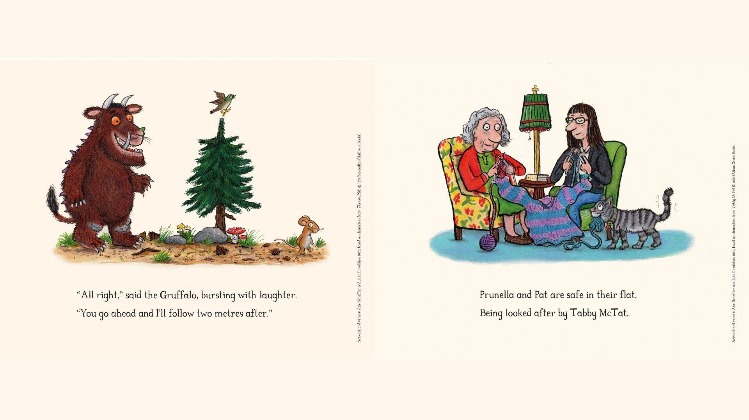

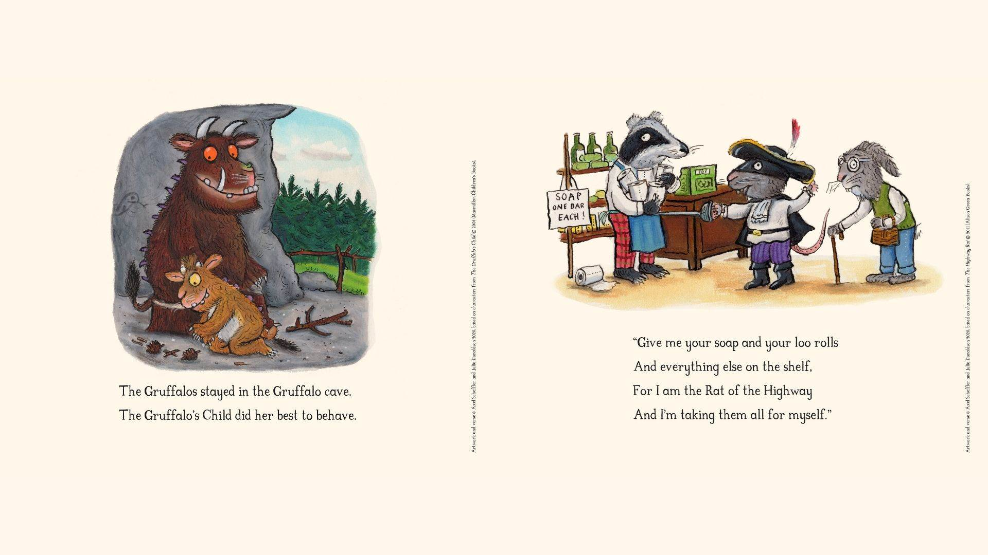

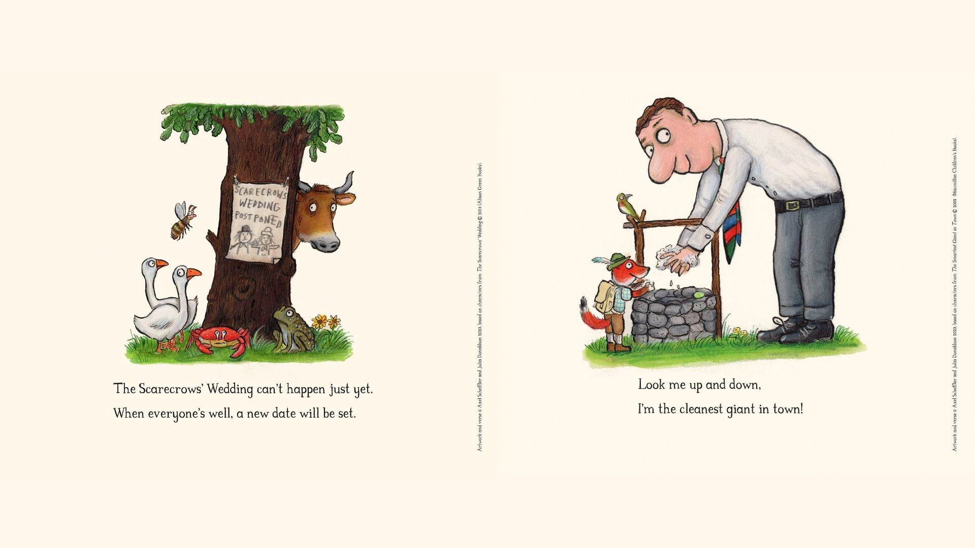

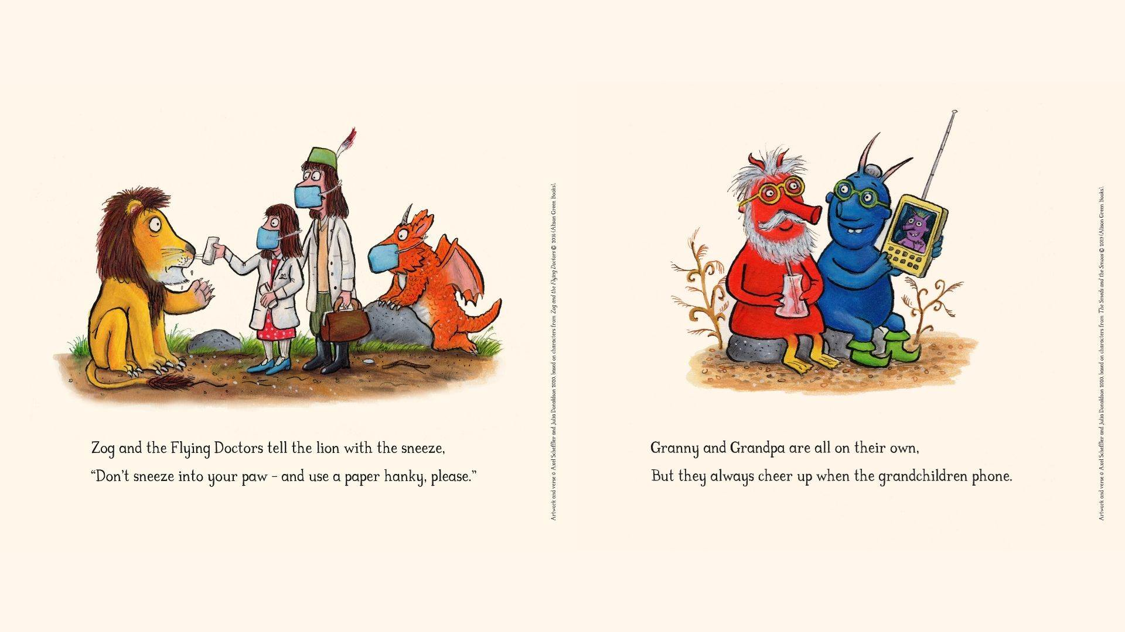
Written by ‘'The Gruffalo' creators Julia Donaldson and illustrated by Axel Scheffler; copied from: https://www.booktrust.org.uk/news-and-features/features/2020/april/the-gruffalo-stick-man-and-the-smartest-giant-in-town-lend-a-paw-a-stick-and-a-hand-to-help-with-the-coronavirus-effort/, 16.04.2020]

