Suggested Easter Holiday activities:

- Easter Hunt: Can you design an Easter themed hunt indoors or outdoors? Can you cut and decorate some eggs on paper/card. Can you write your clues on the eggs to help people find them? Is there a special prize at the end?
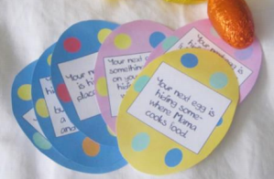https://www.artventurers.co.uk/blog/category/easter-egg-hunt-clues/

- Easter card making: Can you make an Easter card for someone else? What special message will you write inside? Can you post your card on your daily walk? How happy will your recipient be?
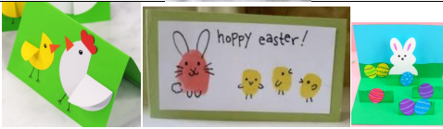https://iheartcraftythings.com/how-to-make-a-pop-up-easter-card.html

- Egg drop challenge: Your mission, if you choose to accept it, is to protect the egg! Design a device that will stop an egg from breaking when dropped from a height. There are lots of egg-xellent design ideas on the internet. Please also be egg-tremely careful and wash your hands after cleaning up any unfortunate egg causalities! Will your egg survive the drop?!
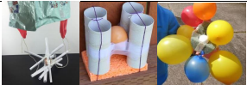

- Easter baskets/nests: Can you make and decorate an Easter basket or nest? What materials will you use? Use the website below for instructions about how to weave a paper basket:
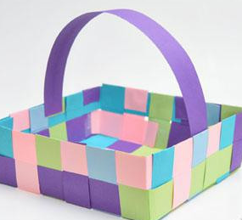

http://allparenting.com/my-family/articles/970733/how-to-weave-a-may-day-basket-with-the-kids

- Chicken or egg? Which came first the chicken or the egg? Can you research and write or present some information on the different stages of a life-cycle of a hen? Can you produce a non-fiction booklet with a page on each stage or do something arty to illustrate your ideas. For those keen scientists, you could look at life cycles of different animals such as amphibians and insects and compare these. Watch this video of a chick hatching and discuss your observations: https://www.youtube.com/watch?v=F38tIGO5TFY
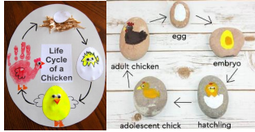

Please upload pictures of your work onto Google Classrooms to share with each other. It would be so uplifting to see everyone’s creations. I will upload my family’s creations!

Most of all guys stay safe, make memories and smile. We will get through this.

Have a fantastic Easter.

Miss you all.

Speak soon,

Miss Battishill

